**RF01 (Shake down flight) - Monday, July 18th, 2016 (Ewan & Armin)**

**Notes on plane**

20:34 Engines on

20:40:20 take off

* Slanted down to surface
* Slanted up to 6000 ft (300 ft/min)
* Some instrument data is wacky but it will be fixed
* Slant down @ 500 ft/min

21:05 About to fly over faint clouds

21:06:00 Over clouds for sure now

21:14 enter cloud 2500 ft

21:15:00 CW 1 on

21:17 clear of clouds

21:36:30 CW 1 off

060/240 Mag heading

22:10:00 Land

**Debrief meeting**

Ewan: we need to eject the USB before the power turns off

Patrick: CPC-1 was intermittent

Armin: LWC was all over the place

Haf: Gerber was dead.

Patrick: What we’re getting is not stratocumulus

Bryce: flight was exactly 1.5 hours

**RF02 - Friday, July 22nd, 2016 (Jimmy & Armin)**

**Notes on plane**

15:15 engines on

15:23:15 take off

15:40 wind shear noted

* Tops @ 600 ft & quite level 20 ft/min

15:50 tops increased to ~800 ft

21:32:00 Landing

Ewan’s cloud water collector (we labelled it NASA CW):

Vial Time Who has it?

1 15:58:31 – 16:07:58 Ewan

2 16:08:21 – 16:10:49 Ewan

3 16:11:01 – 16:14:52 Ewan

4 16:15:09 – 16:29:00 Ewan

5 16:29:17 – 16:39:55 Ewan

6 16:39:59 – 16:50:10 Ewan (15 ml) + Peter (7 ml)

7 16:50:20 – 17:01:44 Ewan (14 ml) + Peter (7 ml)

8 17:02:03 – 17:12:58 Ewan (15 ml) + Peter (7 ml)

9 17:13:13 – 17:23:16 Ewan

10 17:23:23 – 17:36:14 Ewan

11 17:36:20 – 17:42:14 Ewan

12 17:42:24 – 17:53:15 Ewan

13 17:53:20 – 18:04:49 Ewan

14 18:05:11 – 18:21:47 Ewan

15 18:22:03 – 18:53:15 (big vial*) Ewan (5 ml) + Peter (24 ml)

16 18:54:51 – 19:39:00 (big vial*) Ewan (5 ml) + Peter (30)

* Big vial refers to one of Armin’s ~25 ml vials, which have a different cleaning procedure than Ewan’s 15 ml vials. During the flight, Ewan’s vials ran out, so Armin’s vials were used instead. Armin’s vials were cleaned by rinsing 3 times with MilliQ water followed by one rinse with ethanol and then let to dry; Ewan’s vials were cleaned by rinsing 3 times with MilliQ water, followed by 12-24 hour soak in MilliQ water, followed by rinsing 3 times with MilliQ water.

Armin’s cloud water collector (we labelled it UA CW):

Vial Time Who has it?

1 15:57:41 – 16:24:15 Armin (5ml) + Peter (20ml)

2 16:24:28 – 17:07:45 Armin (5ml) + Peter (20ml)

3 17:07:45 – 17:38:42 Armin (5ml) + Peter (20ml)

4 17:38:42 – 18:04:08 Armin (5ml) + Peter (20ml)

5 18:04:12 – 18:50:29 Armin (5ml) + Peter (20ml)

6 18:50:35 – 19:27:52 Armin (5ml) + Peter (20ml)

7 19:28:05 – 19:53:17 Armin (5ml) + Peter (20ml)

**Miscellaneous**

Patrick sent this photo to us during the flight:

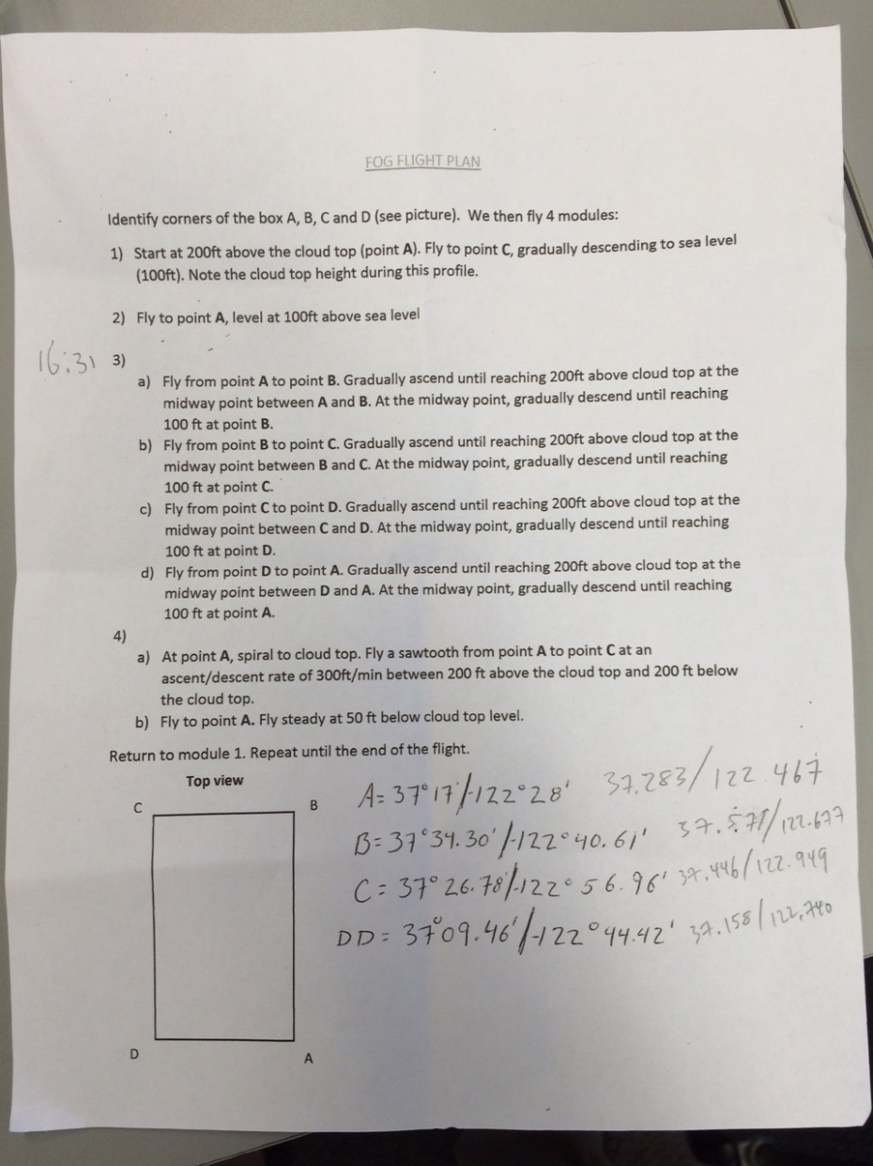

**Debrief meeting**

Bryce: Take off at 8:22. Never got below 800 ft. Other aircraft in the area and made a descent to avoid it. Most flights were between 300-1300 ft. Last 2 legs were hard to hold steady descent. Our rate of measurement [of altitude] is very coarse. 5.2 hours total. Good communication. No issues in doing the box again. All the spirals were done at the “D” corner. We put the 3rd seat in.

Armin: That 3rd seat might be an obstacle. Also, there was a leak from the ceiling dripping onto the LGR.

Patrick: Let´s assume we are going on Monday; it’s weather dependent.

Marco: 6:00 am is the cut off to know what the flight plan will be. We don’t fuel if we don’t fly.

Bryce: Hear from you guys on Saturday or Sunday.

**In the lab after the flight**

The cloud water in the bottles was split such that Peter (the mercury guy) got ~20 ml and we got ~5 ml. Since Ewan’s cloud water collector got so much water, Ewan gave some of his water to Armin, namely, his vials 15 & 16. Two blanks from the Hegg collector were given to Peter (one before the flight and one after). One blank from Ewan’s collector was also given to Peter. For us, one blank before the flight was enough. What was given to Peter was:

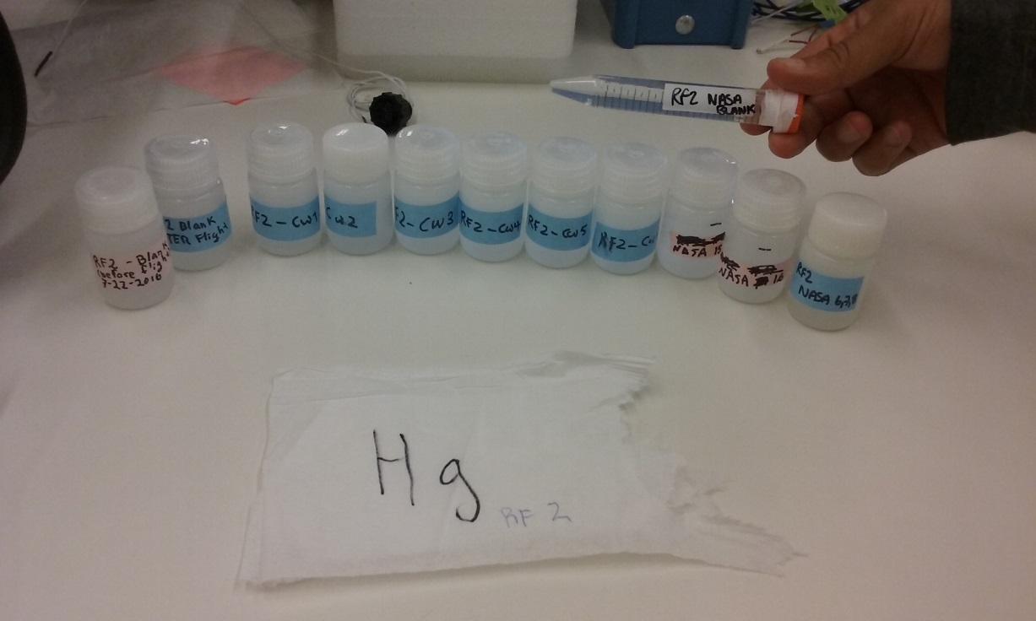

What we kept was:

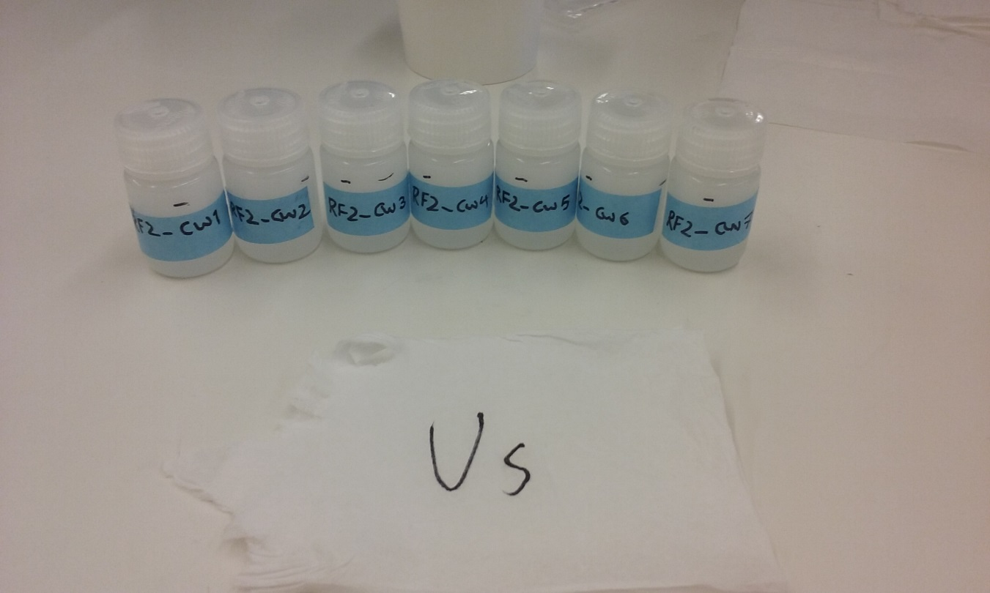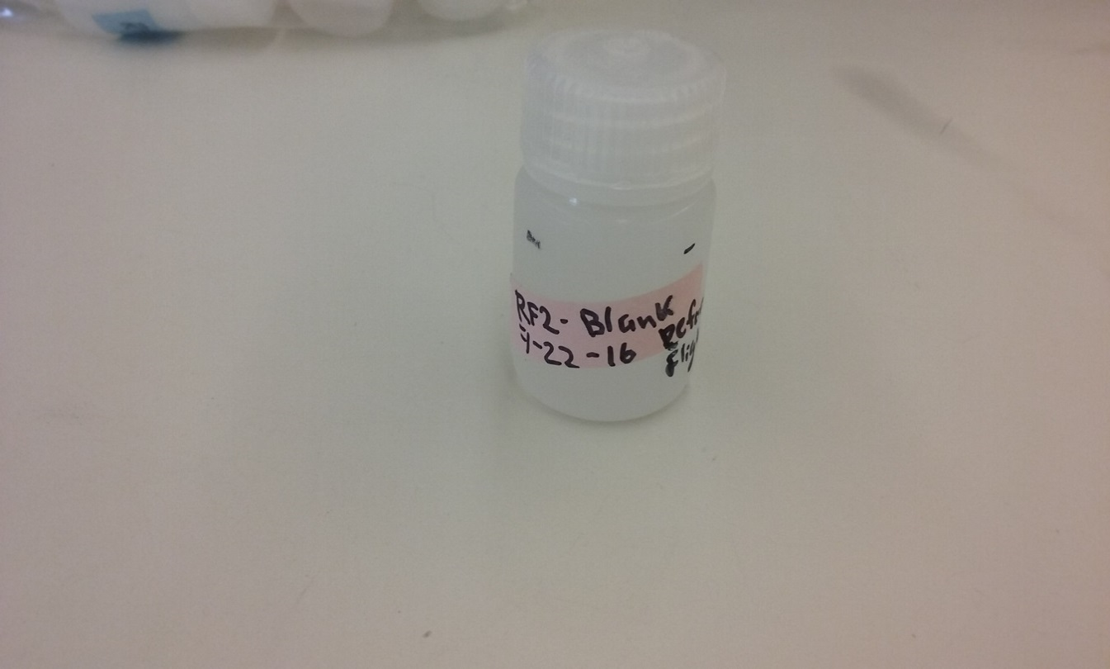

**RF03 - Monday, July 25th 2016 (Ewan & Armin)**

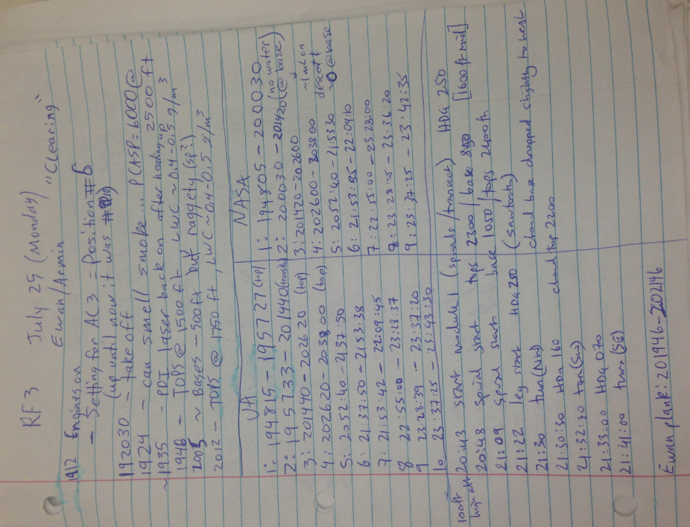

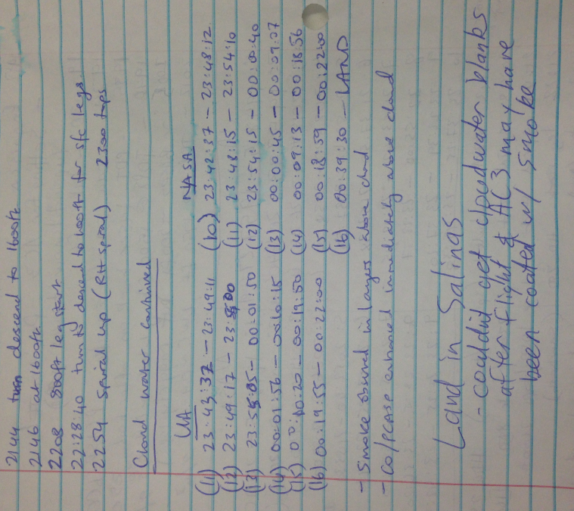

**RF04 - Tuesday, July 26th 2016 (Hossein & Armin)**

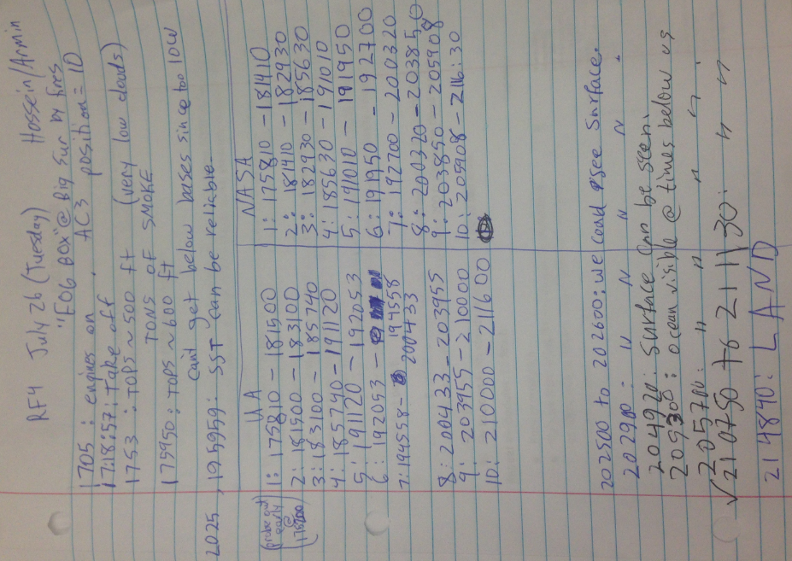

**RF05-Wednesday, July 27th 2016 (Summer & Armin)**

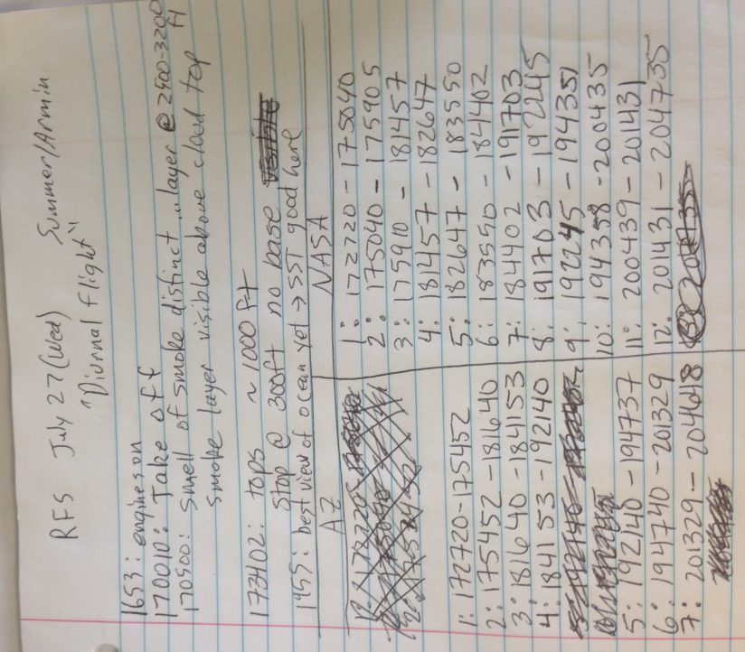

**RF06-Friday, July 29th 2016 (Ewan & Armin)**

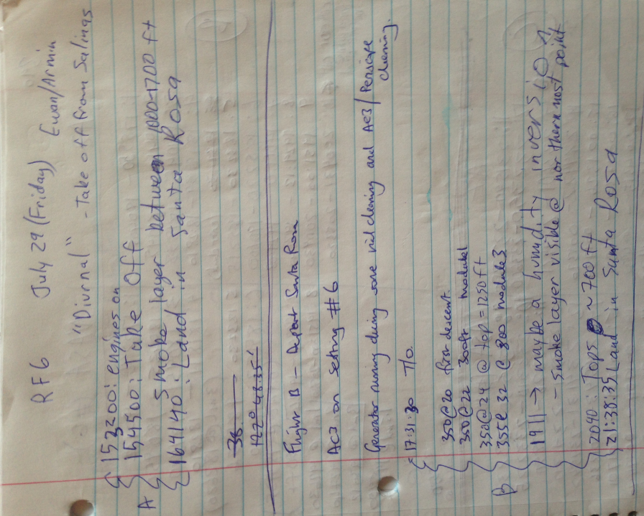

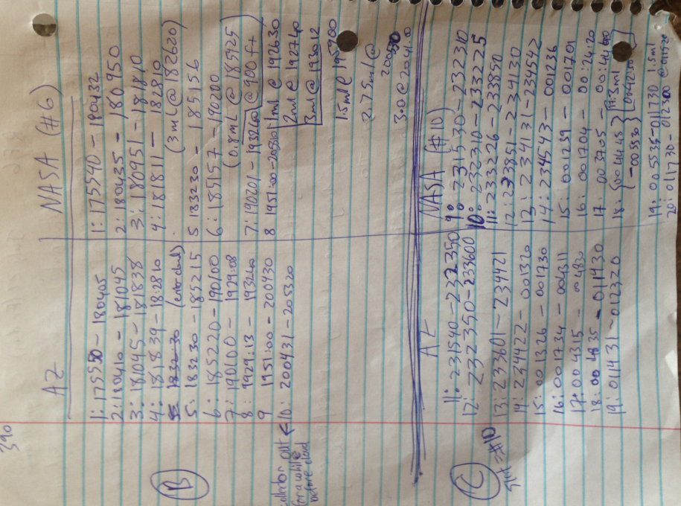

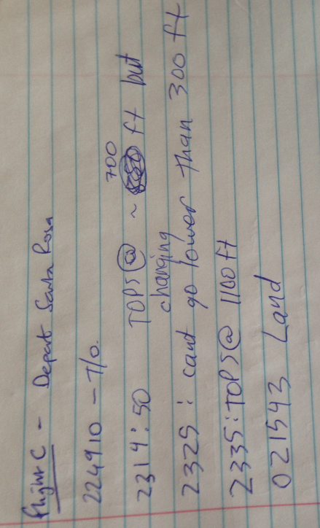

**RF07-Monday, Aug 1st 2016 (Summer & Armin)**

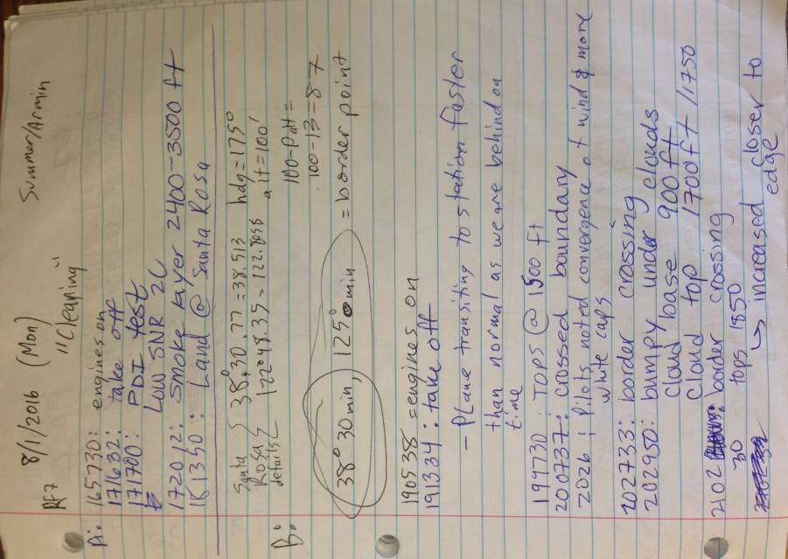

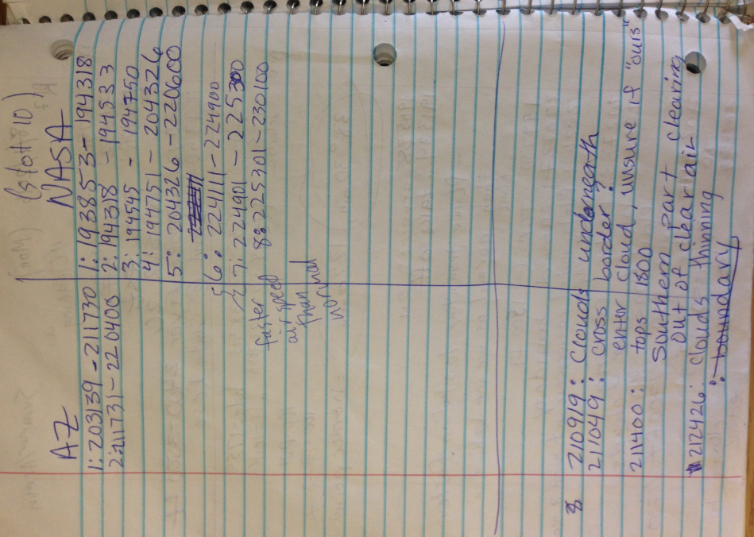

**RF08-Tuesday, Aug 2nd 2016 (Hossein & Armin)**

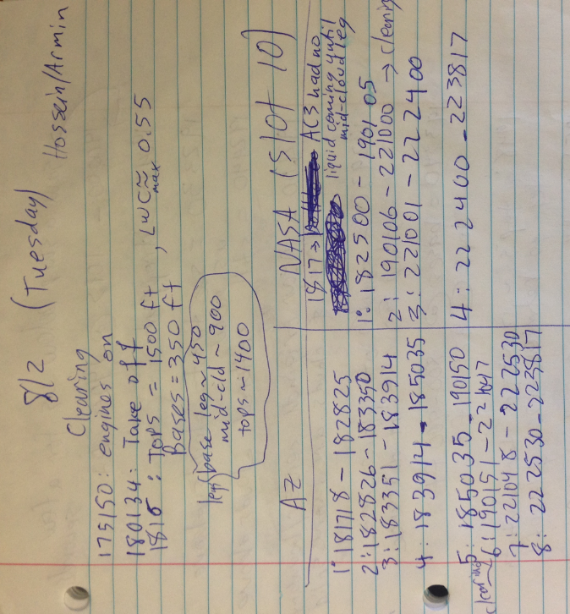

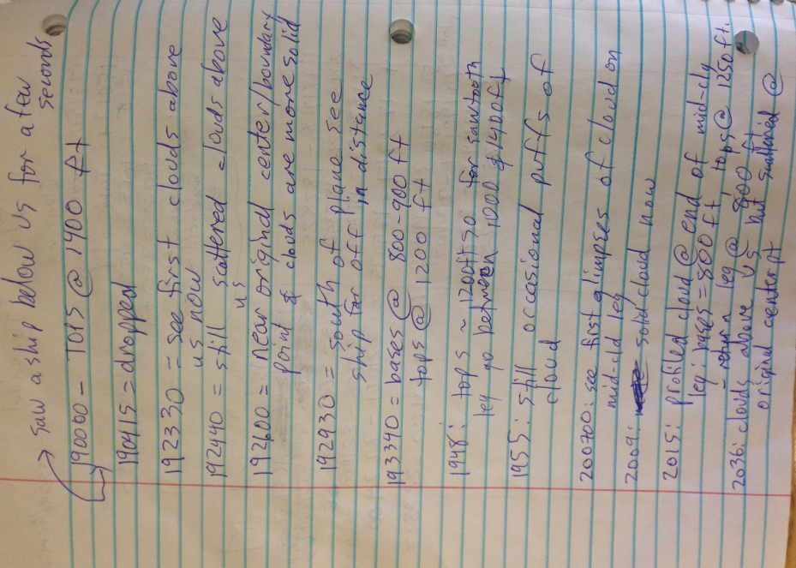

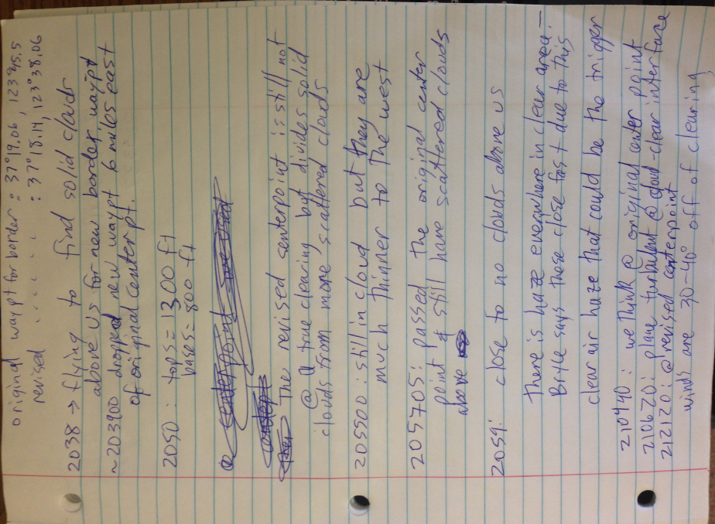

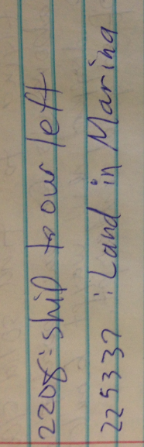

**RF09-Wednesday, Aug 3rd 2016 (James & Armin; Summer and Hossein)**

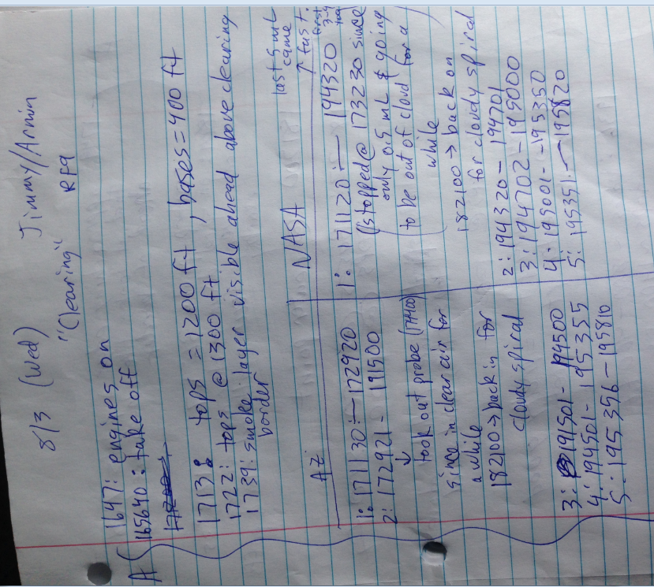

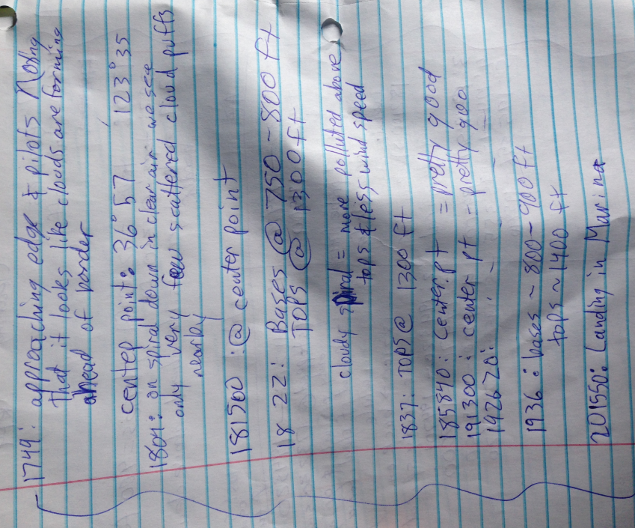

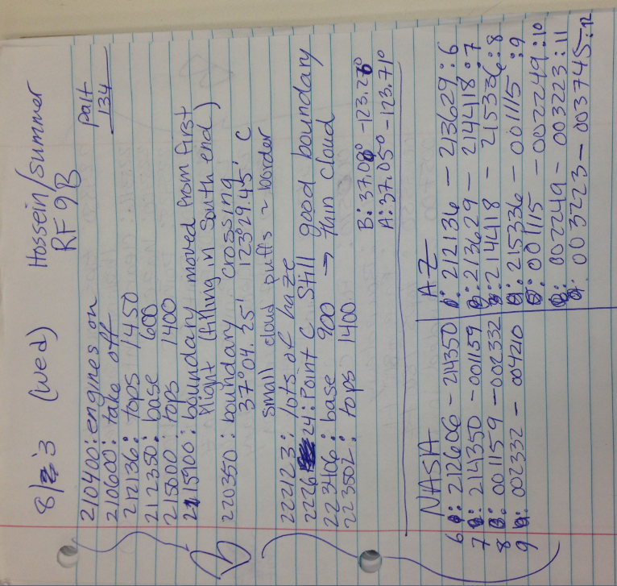

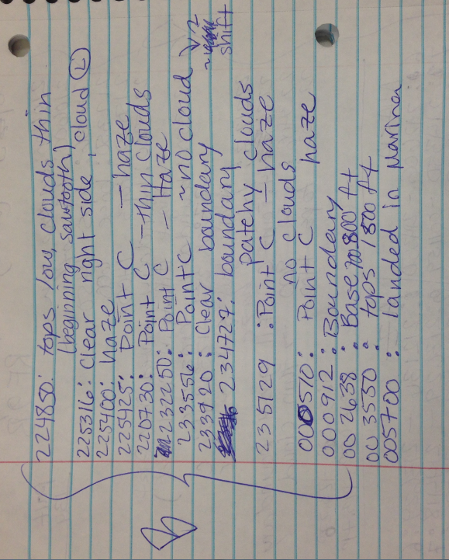

**RF10-Thursday, Aug 4th 2016 (James & Summer)**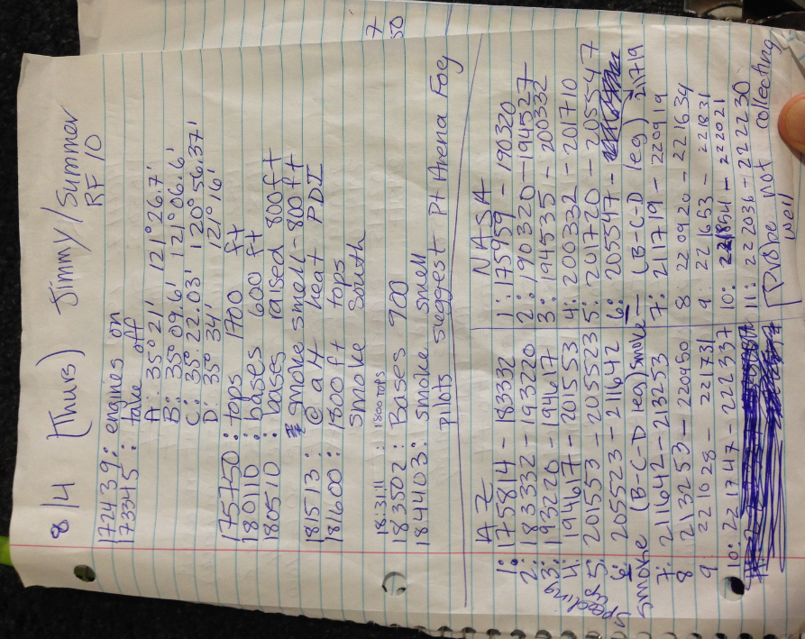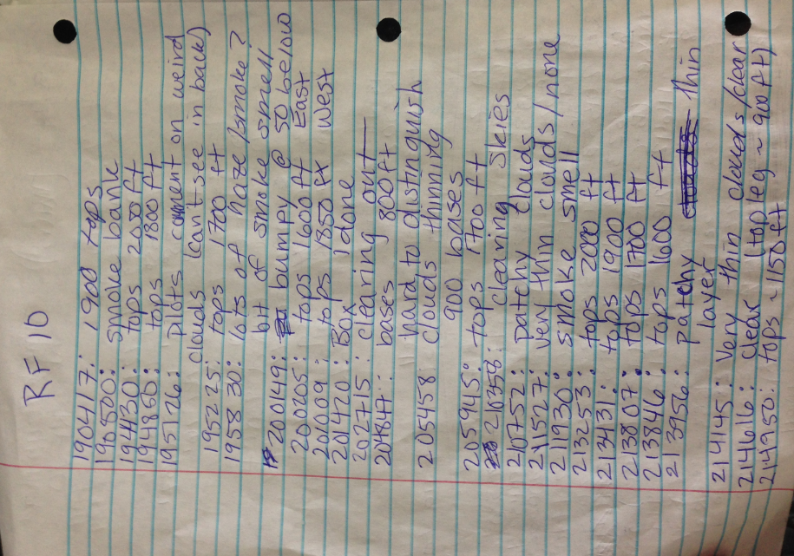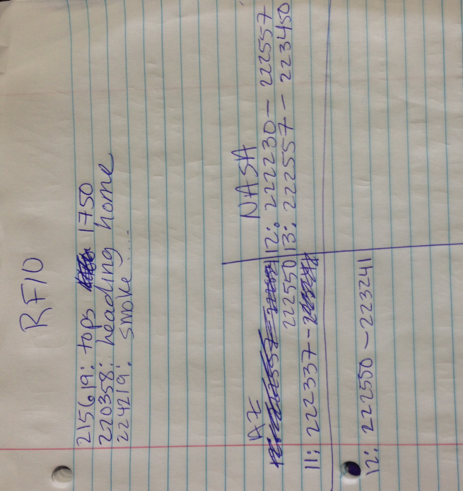

**RF11-Friday, Aug 5th 2016 (Armin & Summer)**

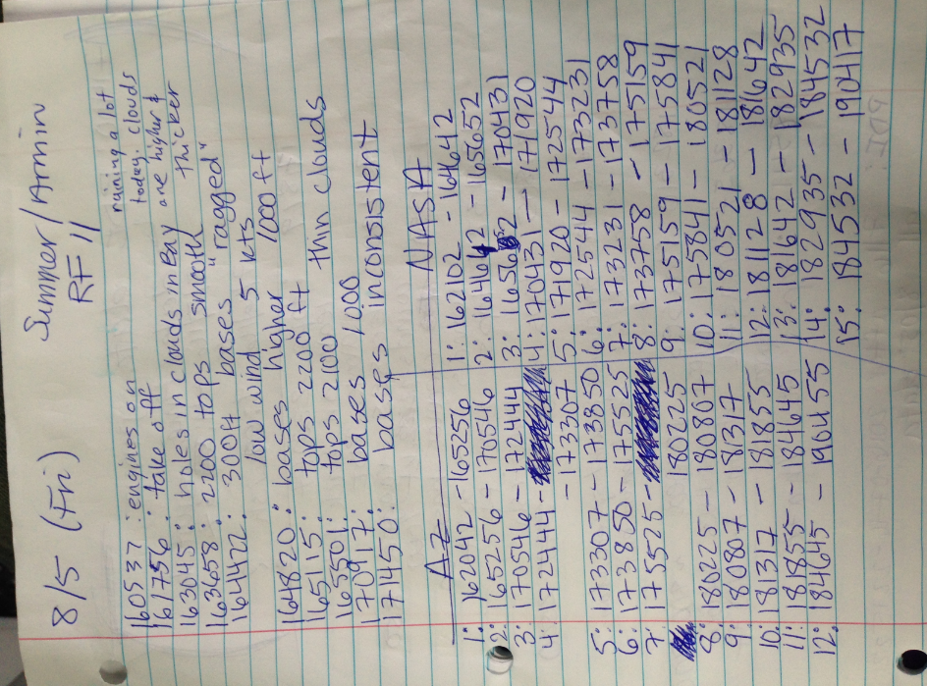

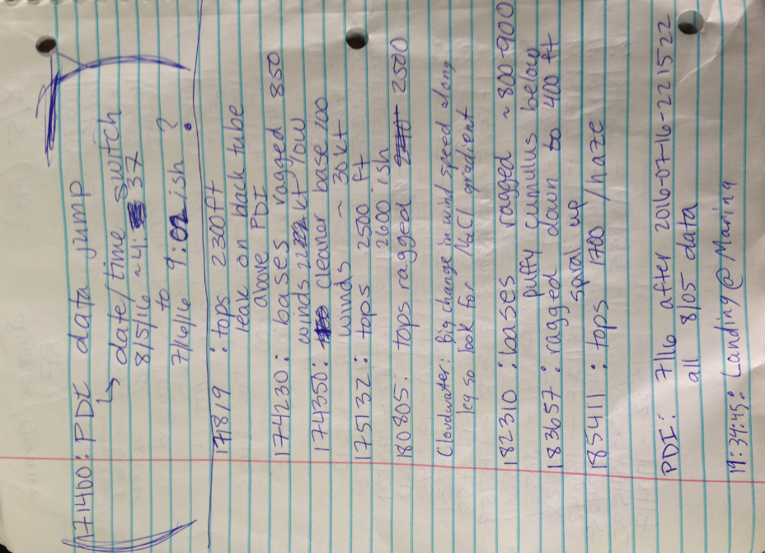

**RF12-Monday, Aug 8th 2016 (Armin & Hossein)**

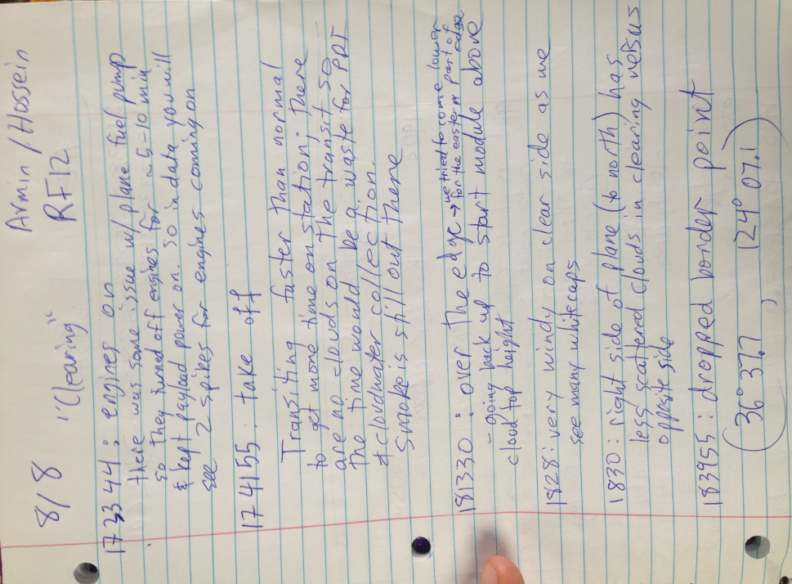

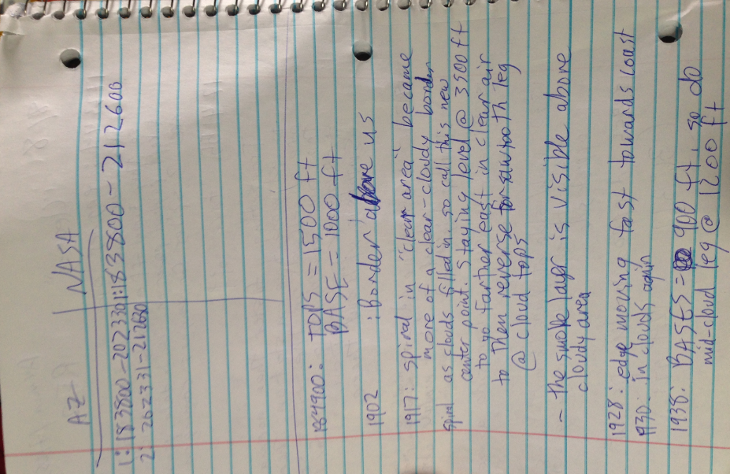

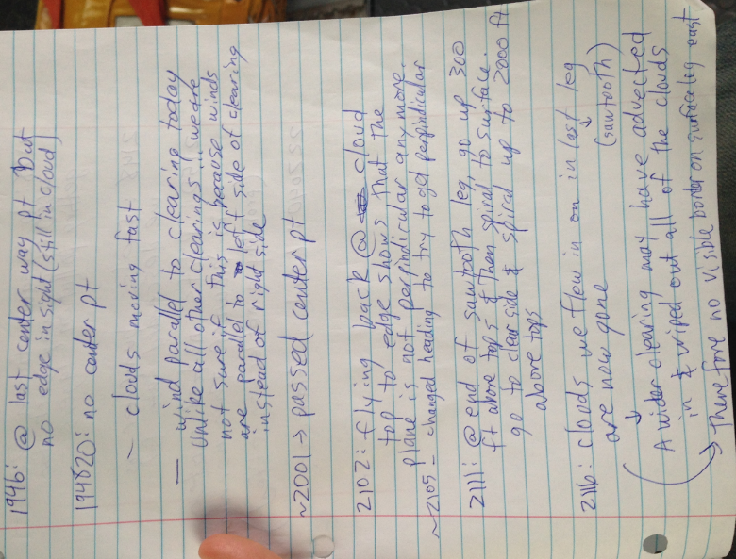

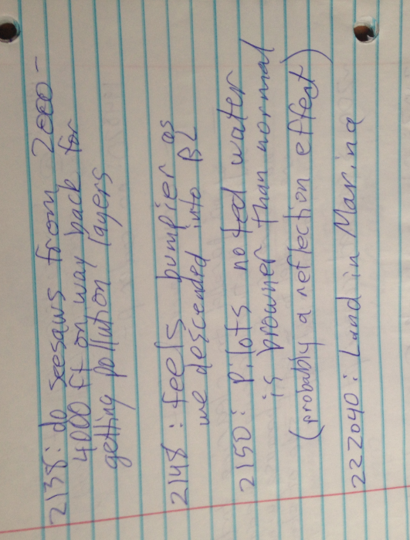

**RF13-Tuesday, Aug 9th 2016 (Summer & James)**

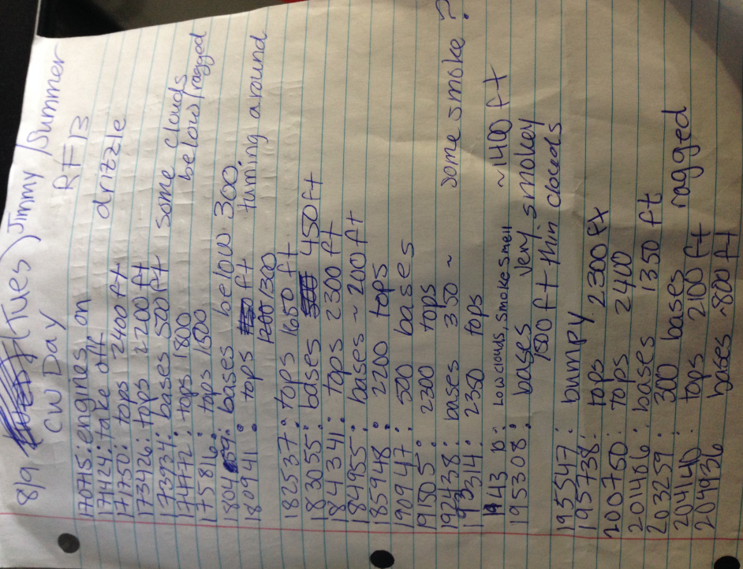

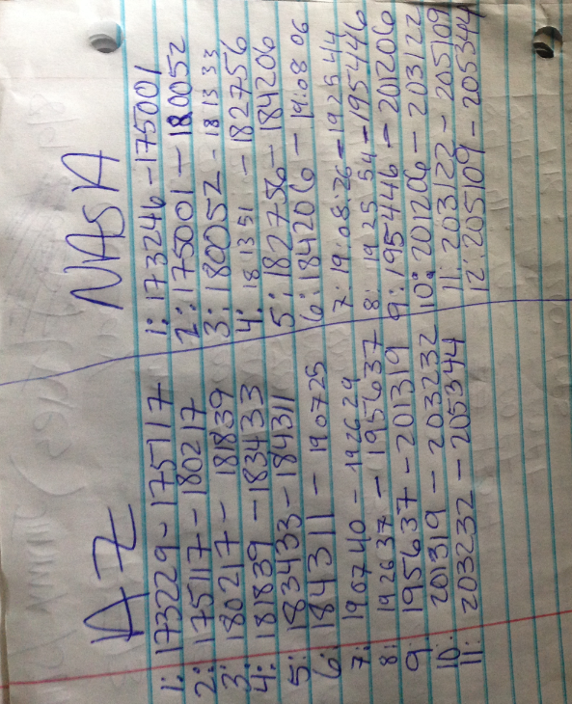

**RF14-Wednesday, Aug 10th 2016 (Hossein & Armin)**

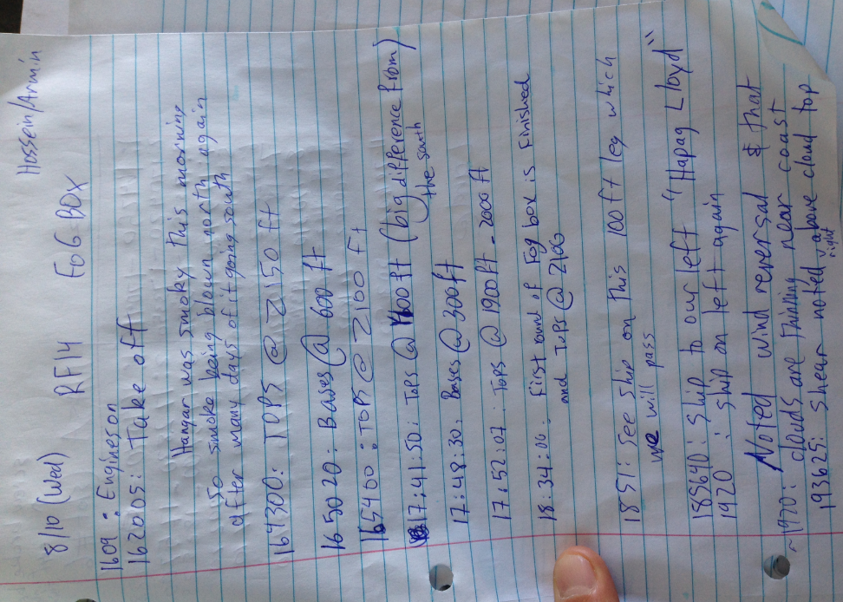

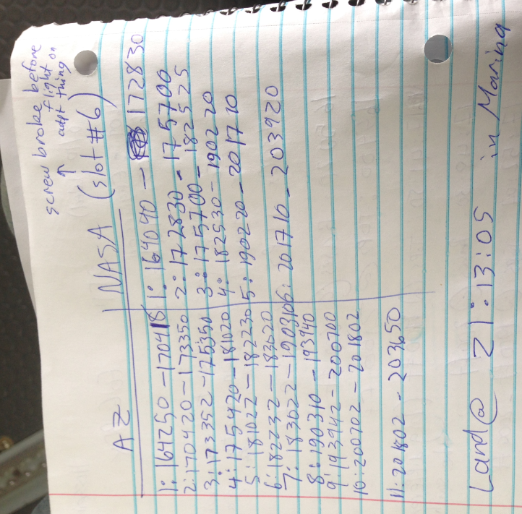

**RF15-Thursday, Aug 11th 2016 (Armin)**

